Dev Diaries
  - Hunt through online development traces to uncover what was left behind.
Image Taken from Challenge hosted on TryHackMe Platform — source
Background
We have just launched a website developed by a freelance developer. The source code was not shared with us, and the developer has since disappeared without handing it over.
Despite this, traces of the development process and earlier versions of the website may still exist online.
You are only given the website’s primary domain as a starting point: marvenly.com
TryHackMe Room Link: Dev Diaries
Answer the questions below
Q. What is the subdomain where the development version of the website is hosted?
As a starting point for this challenge, a domain was given, “marvenly.com”. To know the subdomains, I’ve used Virus Total. Under the relations tab, you will see three subdomains:
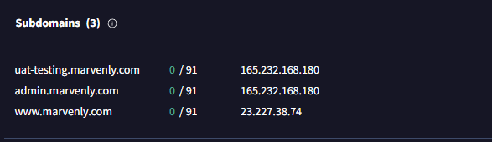
Since it's a development version, the first one only makes sense.
Answer: u********.com
Q. What is the GitHub username of the developer?
At the time of writing this blog, the domain was down for some reason, so I visited a cached version of it through the Wayback Machine and found the GitHub username in the footer of the website.
Press enter or click to view image in full size
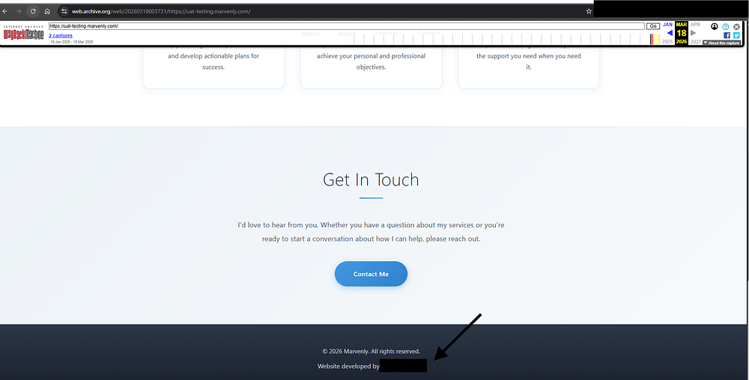
Answer: n******23
Q. What is the developer’s email address?
Now that I’ve got access to his GitHub account, I started exploring his account. He only has one repository named “marvenly_site”. The repository contains an “index.html” which, when opened, has a “Domain for Sale” message but nothing related to his email address.
So I started looking at different commits he has done in past. There was a total of 4 commits so far, I started with the Initial commit and looking at the patch data for it revealed his email address, which can be done by adding .patch at the end of commit URL.
Answer: free***********ail.com
Q. What reason did the developer mention in the commit history for removing the source code?
If you look at the commit with the hash ID “88baf1d” the reason for removing the source code was mentioned.
Press enter or click to view image in full size
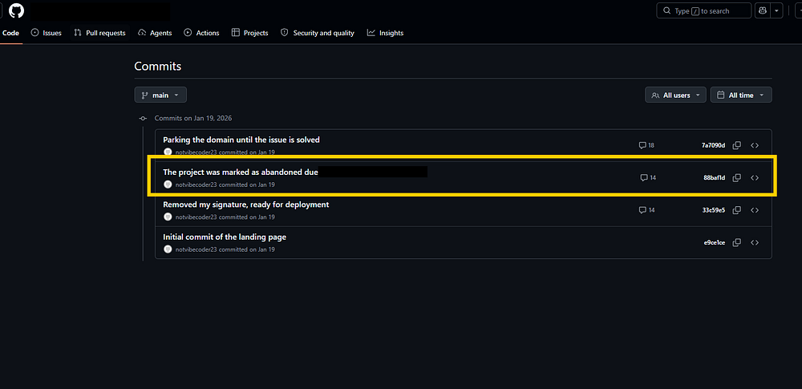
Answer: The project was marked as abandoned due to ***********
Q. What is the value of the hidden flag?
If you review the third commit with ID “33c59e5”, the flag was mentioned in the HTML itself.
Answer: THM{g1********3ts}

___________
“Never Miss Two Days in a Row, Because One Miss Is A Mistake, But Two Is A Building of New Bad Habit.” ~ James Clear
___________

